**Experiment 12:**

**Aim:**Design DFA to accept bcaaaaaaaaa,bc,and c

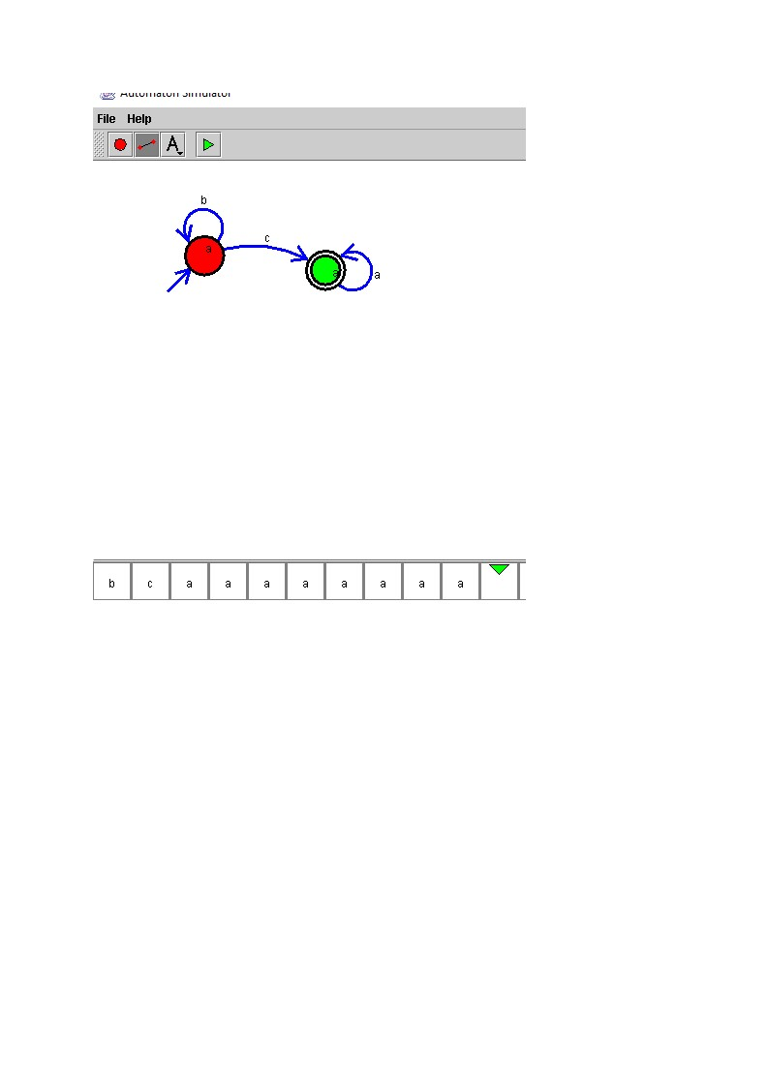**Design and output:**